GOVERNMENT COMPLAINT MANAGEMENT SYSTEM

A MINI PROJECT REPORT

Submitted by

Musap Kathir M (Reg. No. 9517202309073) Surya M (Reg. No. 9517202309114)
Veeramani B (Reg. No. 9517202309120)

23AD652 – Full Stack Development Laboratory

During
VI Semester 2025 – 2026


DEPARTMENT OF ARTIFICIAL INTELLIGENCE AND DATA SCIENCE

MEPCO SCHLENK ENGINEERING COLLEGE, SIVAKASI
(An Autonomous Institution affiliated to Anna University Chennai)
May 2026




MEPCO SCHLENK ENGINEERING COLLEGE, SIVAKASI
(An Autonomous Institution affiliated to Anna University Chennai)

DEPARTMENT OF ARTIFICIAL INTELLIGENCE AND DATA SCIENCE

BONAFIDE CERTIFICATE

Certified that this project report titled Government Complaint Management System is the bonafide work of Musap Kathir M (Reg. No. 9517202309073), Surya M (Reg. No. 9517202309114) and Veeramani B (Reg. No. 9517202309120) who carried out this work under my guidance for the course "23AD652 – Full Stack Development Laboratory" during the sixth semester.

SIGNATURE OF GUIDE SIGNATURE OF H.O.D

Dr. J. Angela Jennifa Sujana, Professor & Head of Department, Department of Artificial Intelligence and Data Science.
Mepco Schlenk Engineering College (Autonomous)
Sivakasi.
Dr. J. Angela Jennifa Sujana, Professor & Head of Department, Department of Artificial Intelligence and Data Science
Mepco Schlenk Engineering College (Autonomous)
Sivakasi.

Submitted for viva-Voice Examination held at MEPCO SCHLENK ENGINEERING COLLEGE (Autonomous), SIVAKASI on / 05 / 26.

ACKNOWLEDGEMENT

First and foremost, we express our deepest gratitude to the LORD ALMIGHTY for His abundant blessings, which have guided us through our past, present, and future endeavors, making this project a successful reality.
We extend our sincere thanks to our management, esteemed Principal, Dr.S. Arivazhagan, M.E., Ph.D., for providing us with a conducive environment, including advanced systems and well-equipped library facilities, which have been instrumental in the completion of this project.
Our heartfelt appreciation goes to our project guide Dr. J. Angela Jennifa Sujana, Professor & Head of Department, Department of Artificial Intelligence and Data Science for their unwavering support, insightful suggestions, and expert guidance. Their experience and encouragement have been vital in shaping our project and helping us bring forth our best.
We are profoundly grateful to our Head of the Artificial Intelligence and Data Science Department, Dr. J. Angela Jennifa Sujana, M.Tech., Ph.D., for granting us this golden opportunity to work on a project of this significance and for her invaluable guidance and encouragement throughout.
We also extend our sincere gratitude to all our faculty members, lab technicians, and our beloved family and friends, whose timely assistance and moral support played a pivotal role in making this mini-project a success.

ABSTRACT

The Government Complaint Management System is a full-stack web application designed to empower citizens of Tamil Nadu to submit, track, and follow up on public service complaints. The system facilitates efficient complaint resolution through a structured three-role architecture consisting of Citizens (Users), Government Officials (Admins), and District Supervisors (Collectors).
Citizens can Register, file complaints categorized under Electricity, Water, Road, Sanitation, and Other public service sectors, attach images, and receive real-time status updates. The system incorporates intelligent features including automatic priority detection based on complaint keywords, hotspot identification when multiple complaints arise from the same location, and smart admin assignment based on availability and workload.
Administrators are assigned complaints automatically and can update statuses through a Pending to In Progress to Resolved workflow. Citizens can submit star ratings and feedback for resolved complaints, and can also escalate concerns by filing complaints against admins for poor performance.
District Collectors have access to a comprehensive monitoring dashboard featuring Recharts-powered analytics including bar charts, pie charts, and line charts for category distribution, monthly trends, and priority breakdowns. A multi-factor admin performance scoring engine evaluates each official based on resolution rate, delayed complaints, average resolution time, and citizen ratings.
The technology stack includes React 18 with React Router DOM on the frontend, Node.js with Express on the backend, MongoDB with Mongoose for data persistence, JWT-based authentication with role-based access control, and Multer for image uploads. The system demonstrates a scalable, citizen-centric approach to digital governance and public accountability.

TABLE OF CONTENTS

CHAPTER NO. | TITLE | PAGE NO.
 | ABSTRACT | iii
 | LIST OF TABLES | v
 | LIST OF FIGURES | vi
1 | INTRODUCTION | 1
2 | SUSTAINABILITY GOALS | 4
3 | SYSTEM ARCHITECTURE | 6
 | 3.1 Overall System Design | 6
 | 3.2 Role-Based Architecture | 6
 | 3.3 Block Diagram | 7
 | 3.4 System Data Flow | 8
 | 3.5 Admin Performance Score Formula | 9
 | 3.6 API Endpoint Summary | 10
4 | SYSTEM IMPLEMENTATION | 11
 | 4.1 Backend Implementation | 11
 | 4.2 Frontend Implementation | 12
 | 4.3 Database Schema | 13
5 | RESULT ANALYSIS | 15
6 | CONCLUSION AND FUTURE ENHANCEMENTS | 22
APPENDIX  – A | SOURCE CODE | 24
 | REFERENCES | 33

LIST OF TABLES

Table No. | Table Caption | Page No.
3.1 | Role-Based Access Summary | 7
3.2 | Admin Performance Score Components | 9
3.3 | API Endpoints – Authentication & Complaints | 10
3.4 | API Endpoints – Admin Complaints & Performance | 10
4.1 | Database Schema – User Model | 13
4.2 | Database Schema – Complaint Model | 14
5.1 | Feature Summary Table | 15
5.2 | System Test Results | 16

LIST OF FIGURES

Figure No. | Figure Caption | Page No.
1.1 | Government Complaint Management System –  Overview | 3
2.1 | SDG 16 – Peace, Justice and Strong Institutions | 4
2.2 | SDG 11 – Sustainable Cities and Communities | 4
2.3 | SDG 10 – Reduced Inequalities | 5
3.1 | Block Diagram of the System | 7
3.2 | System Data Flow Diagram | 8
4.1 | Complaint Lifecycle State Machine | 12
5.1 | Login Page | 17
5.2 | Complaint Page | 17
5.3 | Report Admin Page | 18
5.4 | Service Complaints Page | 18
5.5 | Admin Analytics Page | 19
5.6 | Resolve Complaint Page | 19
5.7 | Collector Dashboard | 20
5.8 | Total District Complaint Page | 20
5.9 | Collector Solved Complaint Page | 21
5.10 | Admin Performance Metrics Page | 21

CHAPTER 1 INTRODUCTION

Background and Motivation
Effective public grievance redressal is a cornerstone of democratic governance. Citizens across Tamil Nadu routinely face issues with essential public services such as electricity supply, drinking water, road maintenance, and sanitation. Traditionally, filing a complaint required visiting government offices in person, enduring long queues, and often receiving no feedback on the outcome. This friction discourages citizen participation and leads to unresolved civic problems that affect quality of life.
The proliferation of smartphones and internet connectivity in both urban and rural Tamil Nadu has created an opportunity to bridge this gap through digital governance. A web-based complaint management system enables citizens to report issues from anywhere, at any time, and track the resolution process transparently. For government administrators, a centralized platform improves accountability, enables workload distribution, and surfaces data-driven insights about recurring problem areas.

Challenges in Existing Systems
The key challenges addressed by this project are as follows:
- Citizens lack a convenient, transparent channel to report public service failures and receive status updates.
- Government administrators handle complaints manually with no systematic assignment or priority mechanism, leading to delays.
- District-level supervisors (Collectors) have no data-driven view of complaint trends, hotspot areas, or individual admin performance.
- There is no accountability mechanism for citizens to report poor service by government officials.

- Recurring complaints in the same location are not automatically identified as hotspots requiring priority attention.

Conventional Methods and Their Limitations
Historically, public grievance redressal relied on the following approaches:
- Manual complaint registration at government offices requiring physical presence and long wait times.
- Paper-based tracking with no visibility to the citizen after submission.
- Arbitrary admin assignment with no workload balancing or availability tracking.
- No aggregated data for district supervisors to identify problem areas or underperforming officials.
While these methods have served governance historically, they have significant drawbacks: inability to detect recurring issues in the same area, high manual overhead, poor scalability, and no citizen feedback loop.

Project Objectives and Scope
This project, the Government Complaint Management System, aims to:
- Build a citizen-facing complaint portal allowing users to submit, track, and provide feedback on complaints.
- Implement intelligent auto-assignment of complaints to available administrators based on district and workload.
- Develop a keyword-driven priority detection engine and hotspot identification mechanism.
- Provide government administrators with a structured complaint resolution workflow with status tracking.
- Build a Collector-level monitoring dashboard with Recharts-powered analytics and admin performance scoring.

- Enable citizen accountability through an admin complaint filing mechanism with multi-factor performance evaluation.
- Implement JWT-based role-specific authentication (User, Admin, Collector) with district-scoped data access.

System Overview
The Government Complaint Management System is a three-role platform built on the MERN-adjacent stack (MongoDB, Express, React, Node.js). The backend exposes a RESTful API secured with JWT tokens, while the frontend React application renders role- specific dashboards with Recharts visualizations. The data flow begins with citizen complaint submission, proceeds through intelligent admin assignment, follows a status workflow of Pending to In Progress to Resolved, and culminates in citizen feedback collection and collector-level performance analytics.
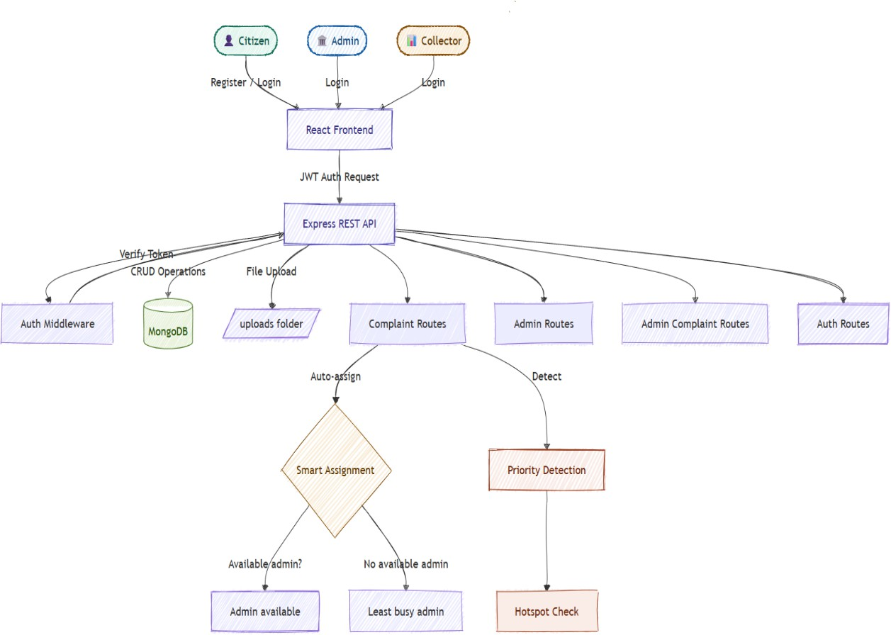

Fig 1.1 Government Complaint Management System – Overview

CHAPTER 2 SUSTAINABILITY GOALS

SDG 16 – PEACE, JUSTICE AND STRONG INSTITUTIONS


Fig 2.1 SDG 16 – Peace, Justice and Strong Institutions

Description: SDG 16 promotes peaceful and inclusive societies for sustainable development, provides access to justice for all, and builds effective, accountable, and inclusive institutions at all levels.
Project Link: The Government Complaint Management System directly embodies SDG 16 by creating a transparent, accountable, and citizen-accessible governance mechanism. The system provides a formal digital channel for citizens to report public service failures and receive documented responses.

SDG 11 – SUSTAINABLE CITIES AND COMMUNITIES


Fig 2.2 SDG 11 – Sustainable Cities and Communities

Description: SDG 11 aims to make cities and human settlements inclusive, safe, resilient, and sustainable, with particular emphasis on adequate and affordable public services.
Project Link: The complaint management system contributes to SDG 11 by enabling rapid response to failures in core urban and rural infrastructure including roads, street lighting, water supply, and sanitation. The hotspot detection feature automatically identifies geographic clusters of repeated complaints, enabling proactive infrastructure maintenance rather than reactive one-off fixes. District-level trend analytics help administrators.

SDG 10 – REDUCED INEQUALITIES


Fig 2.3 SDG 10 – Reduced Inequalities

Description: SDG 10 calls for reducing inequality within and among countries, including improving the access of disadvantaged groups to essential services.
Project Link: Rural and lower-income communities in Tamil Nadu historically face greater barriers to accessing government services and lodging complaints. The Government Complaint Management System addresses this gap by providing a simple, mobile-accessible web portal that requires no physical travel to government offices. The district-based scoping ensures that complaints are routed to the appropriate local official regardless of the complainant's social standing. The priority auto-detection mechanism ensures that urgent complaints from vulnerable areas — such as water contamination or electrical hazards — are escalated automatically, providing equitable responsiveness to all citizens.

CHAPTER 3 SYSTEM ARCHITECTURE

Overall System Design
The Government Complaint Management System is organized as a three-tier web application:
    - Presentation Tier: A React 18 single-page application with React Router DOM for client-side navigation, Recharts for interactive data visualizations, and Axios for HTTP communication with the backend API. Role-specific layouts (UserLayout, AdminLayout, CollectorLayout) provide consistent navigation for each user type.
    - Application Tier: A Node.js Express REST API server handling authentication, complaint management, analytics aggregation, and admin performance evaluation. Middleware layers enforce JWT authentication and role-based access control. Multer middleware handles multipart image uploads.
    - Data Tier: MongoDB with Mongoose ODM provides a flexible document store for users, complaints, and admin complaints. MongoDB aggregation pipelines compute analytics and performance metrics server-side.

Role-Based Architecture
The system supports three distinct user roles, each with scoped data access and dedicated interfaces:

Role | Description | Key Capabilities
User (Citizen) | Registered citizen of Tamil Nadu | Submit complaints, track status, submit feedback, report admin
Admin (Official) | Government official assigned to a district | View assigned complaints, update status, add remarks, resolve

Collector | District-level supervisor | Monitor all district complaints, view analytics, evaluate admin performance
Table 3.1 Role-Based Access Summary

Block Diagram

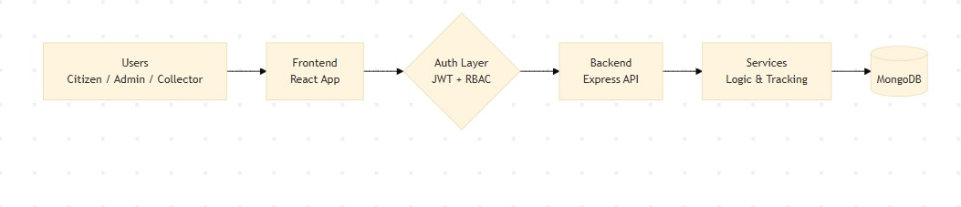

Fig 3.1 Block Diagram

Diagram Explanation
    - User Registration and Authentication: Citizens, Admins, and Collectors register with role and district. JWT tokens are issued on login and verified by middleware on every API request.
    - Complaint Submission Pipeline: Citizen submits complaint through the React frontend; the Express backend runs priority detection, hotspot checking, suggestion generation, and smart admin assignment before storing in MongoDB.
    - Complaint Resolution Workflow: Assigned Admin updates complaint status from Pending to In Progress to Resolved. On resolution, the resolvedAt timestamp is stored and admin availability is restored.
    - Collector Monitoring: Collector accesses district-scoped analytics from the Express API, including aggregated complaint data and admin performance scores computed from multiple factors.

System Data Flow
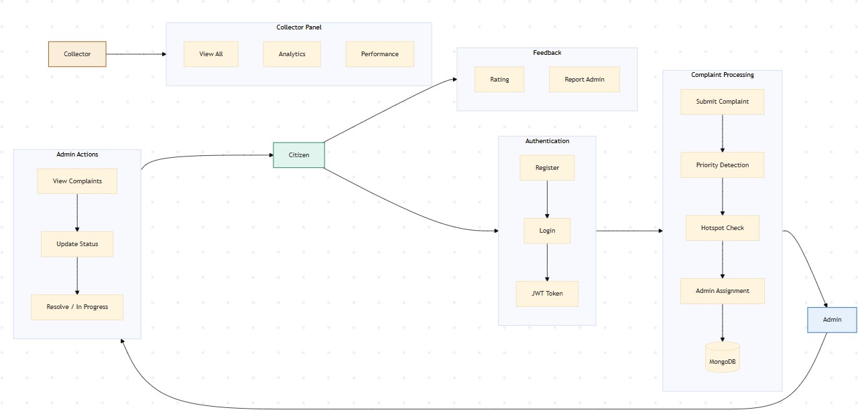

Fig 3.2 System Data Flow Diagram

The data flow of the system follows these stages:
    - Step 1 – Registration/Login: User registers with name, email, password, district, and role. JWT token is returned and stored in localStorage.
    - Step 2 – Complaint Submission: Citizen fills form with title, description, category, location, and optional image. Backend triggers keyword-based priority detection, hotspot checking (3+ complaints at same location within 3 months), suggestion generation, and smart admin assignment.
    - Step 3 – Admin Assignment: System first searches for an available admin in the district. If none is available, it assigns the admin with the fewest active complaints.

    - Step 4 – Resolution: Admin updates status to Resolved, resolvedAt is recorded, and admin's isAvailable flag is restored to true.
    - Step 5 – Feedback and Reporting: Citizen rates the resolved complaint (1–5 stars) and may file an admin complaint for poor service.
    - Step 6 – Analytics: Collector dashboard aggregates complaint counts by status, category, priority, and time. Admin performance engine computes a multi-factor score per official.

Admin Performance Score Formula
The admin performance evaluation engine computes an overall score (0–100) for each government official based on four weighted factors:

Score Component | Formula | Max Pts | Description
Resolution Rate | resolutionRate × 0.4 | 40 | % of assigned complaints resolved
Delay Penalty | (5 − delayed) × 5 | 25 | Complaints pending more than 3 days
Citizen Rating | avgRating × 10 | 50 | Average star rating from citizen feedback
Speed Bonus | +20 or +10 or 0 | 20 | <3 days=20pts, <7 days=10pts,  else 0
Cap | Math.min(100, total) | 100 | Score capped at 100
Table 3.2 Admin Performance Score Components

Score categories: Excellent (80–100, Green), Good (60–79, Orange), Needs Improvement (below 60, Red).

API Endpoint Summary

Authentication & Complaint Endpoints

Method | Endpoint | Description
POST | /api/auth/register | Register new user with role and district
POST | /api/auth/login | Authenticate user and return JWT token
POST | /api/complaints | Create complaint with image upload support
GET | /api/complaints | Get logged-in user's complaints
GET | /api/complaints/all | Get all complaints (admin/collector filtered)
PUT | /api/complaints/:id | Update complaint status and remarks (admin)
POST | /api/complaints/:id/feedback | Submit star rating and feedback
GET | /api/complaints/check-similar | Check for similar recent complaints
GET | /api/complaints/nearby | Get nearby complaints by location
GET | /api/admin/analytics | Get aggregated analytics for dashboard
Table 3.3 API Endpoints – Authentication & Complaints

Admin Complaint & Performance Endpoints

Method | Endpoint | Description
POST | /api/admin-complaints | File a complaint against an admin
GET | /api/admin-complaints | Get all admin complaints (district scoped)
PUT | /api/admin-complaints/:id | Update admin complaint status (collector)
GET | /api/admin- complaints/performance/all | Get all admin performance scores
GET | /api/admin-complaints/my- complaints | Get complaints filed by logged-in user
Table 3.4 API Endpoints – Admin Complaints & Performance

CHAPTER 4 SYSTEM IMPLEMENTATION

Backend Implementation

    - Server Setup (server.js)
The Express application is configured with CORS support, JSON body parsing, and static file serving for uploaded images. MongoDB is connected using Mongoose with the connection string loaded from environment variables. The server registers four route modules and starts listening after a successful database connection.

JWT Authentication Middleware (middleware/auth.js)
The authentication middleware extracts the JWT token from the Authorization header, verifies it using the application secret, and attaches the resolved user document to the request object. Role-specific middleware functions (adminOnly, collectorOnly) enforce access control at the route level.

Smart Admin Assignment Logic
When a complaint is submitted, the system first tries to assign it to an available admin in the same district. If no available admin is found, it computes the workload of all district admins and assigns the complaint to the one with the fewest active (non-resolved) complaints. This prevents any single admin from being overwhelmed.

Priority Detection and Hotspot Identification
Priority is determined by scanning the complaint description for keywords associated with urgent situations. Hotspot detection counts complaints from the same location within the past three months; if three or more exist, the area is flagged and the complaint priority is escalated.

Frontend Implementation

    - Authentication Context (AuthContext.jsx)
Global authentication state is managed using React Context API. The AuthProvider stores the user object and JWT token in localStorage for persistence across page refreshes. The useAuth hook exposes login and logout functions to all child components.

Analytics Aggregation (analyticsController.js)
The analytics controller performs server-side MongoDB aggregation to produce complaint breakdowns by status, category, priority, and time period. All data is district- scoped for Admins and Collectors.
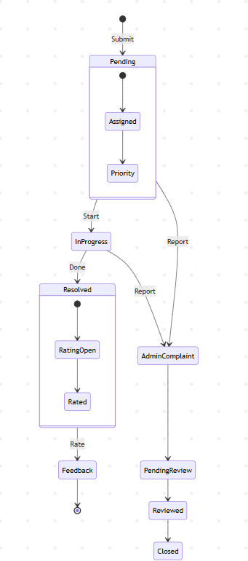

Fig 4.1 Complaint Lifecycle State Machine

Database Schema

User Model

Field | Type | Description
name | String (required) | Full name of the user
email | String (required, unique) | Email address used for login
password | String (required) | Bcrypt-hashed password
role | Enum: user/admin/collector | Role determines access privileges
district | String (required) | Tamil Nadu district for data scoping
isAvailable | Boolean (default: true) | Tracks admin availability for assignment
Table 4.1 Database Schema – User Model

Complaint Model

Field | Type | Description
userId | ObjectId → User | Reference to citizen who filed the complaint
title | String (required) | Short title of the complaint
description | String (required) | Detailed complaint description
category | Enum (5 types) | Electricity / Water / Road / Sanitation / Other
district | String (required) | District where the complaint occurred
location | String | Specific location within the district
status | Enum | Pending / In Progress / Resolved
priority | Enum | High / Medium / Low (auto-detected)
assignedAdmin | ObjectId → User | Admin assigned to resolve the complaint

isFrequentArea | Boolean | True if 3+ complaints at this location in 3 months
resolvedAt | Date | Timestamp when complaint was resolved
rating | Number (1–5) | Citizen star rating after resolution
suggestion | String | Auto-generated resolution suggestion
Table 4.2 Database Schema – Complaint Model

CHAPTER 5 RESULT ANALYSIS

Feature Summary

Feature | Description | Status
Role-Based Authentication | JWT tokens with User/Admin/Collector roles | Implemented
Complaint Submission | Form with image upload, category, location | Implemented
Priority Auto-Detection | Keyword scanning for High/Medium/Low priority | Implemented
Hotspot Detection | 3+ complaints at same location in 3 months | Implemented
Smart Admin Assignment | Available-first, then least-busy fallback | Implemented
Complaint Status Workflow | Pending → In Progress → Resolved | Implemented
Citizen Feedback System | Star rating and text feedback for resolved complaints | Implemented
Admin Accountability | Citizens can file complaints against admins | Implemented
Admin Performance Score | Multi-factor: resolution, delay, rating, speed | Implemented
Analytics Dashboard | Bar, pie, and line charts with Recharts | Implemented
District Data Scoping | All data filtered by user district | Implemented
Image Upload | Multer-based file storage for complaint images | Implemented
Table 5.1 Feature Summary Table

System Test Results

Test Case | Expected Output | Result
User Registration with valid data | JWT token + user object returned | Pass
Login with wrong role selected | Error: Not a [role] account | Pass
Complaint with "live wire" in description | priority = High assigned automatically | Pass
4th complaint at same location in 3 months | isFrequentArea = true, priority elevated | Pass
Admin marks complaint Resolved | resolvedAt set, admin isAvailable restored | Pass
Citizen submits feedback for resolved complaint | Complaint updated with rating and feedback | Pass
Admin performance score calculation | Score = min(100, formula result) | Pass
Collector requests analytics | District-scoped aggregated data returned | Pass
User attempts to access admin route | 403 Forbidden response returned | Pass
Table 5.2 System Test Results

The system demonstrates efficient operation across all three user roles. Complaint submission completes end-to-end — including priority detection, hotspot checking, and admin assignment — within acceptable response times. MongoDB aggregation pipelines for analytics execute efficiently for moderate data volumes. The admin performance scoring engine processes all district admins in a single API call with parallel Promise.all execution.

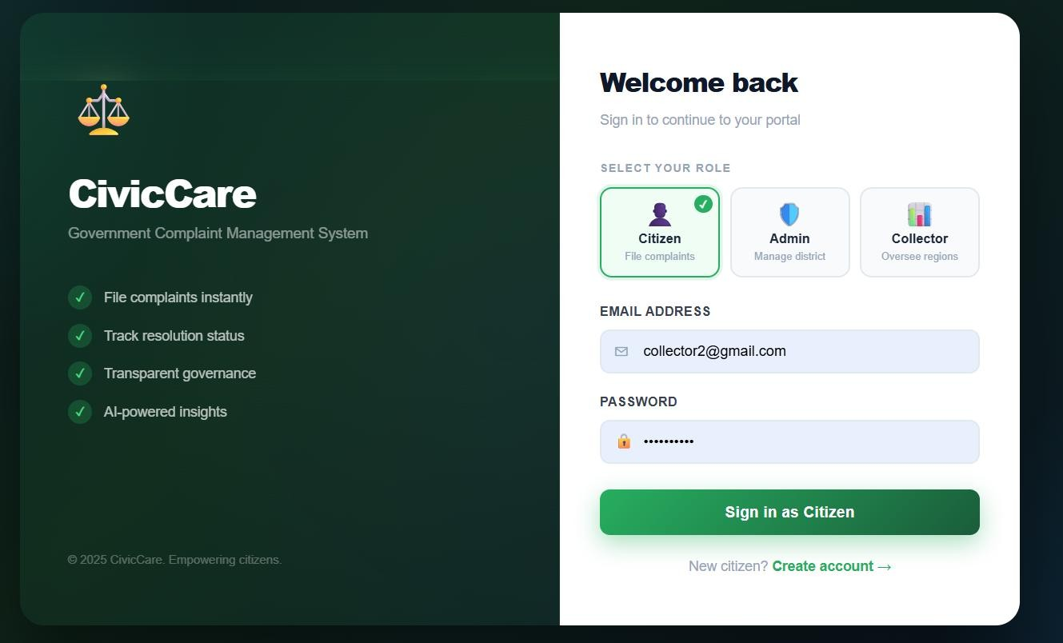
Fig 5.1 Login Page
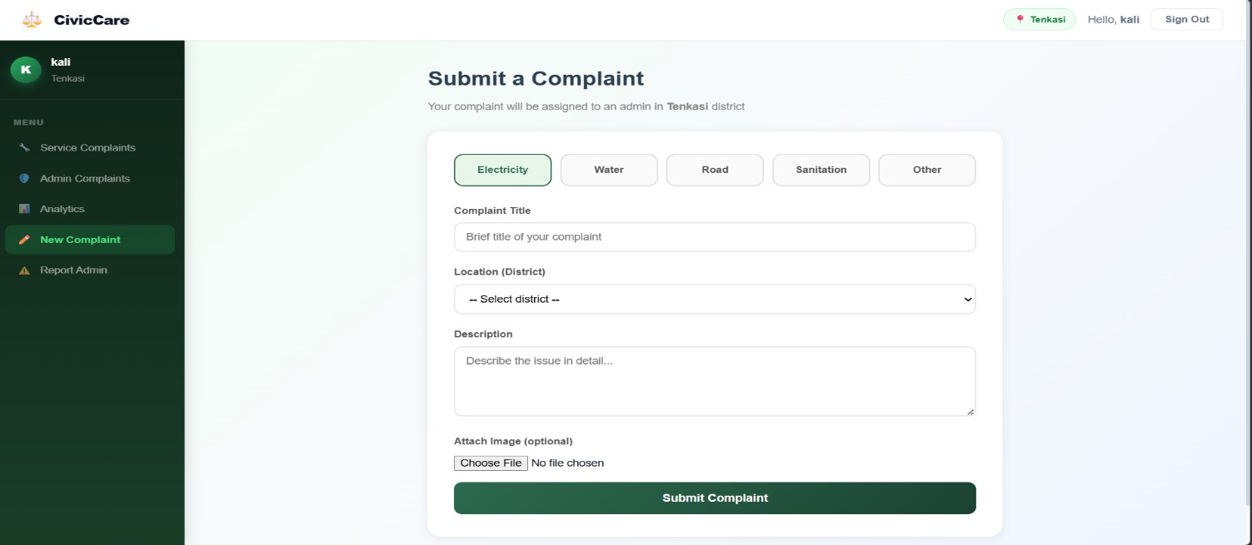
Fig 5.2 Complaint Page

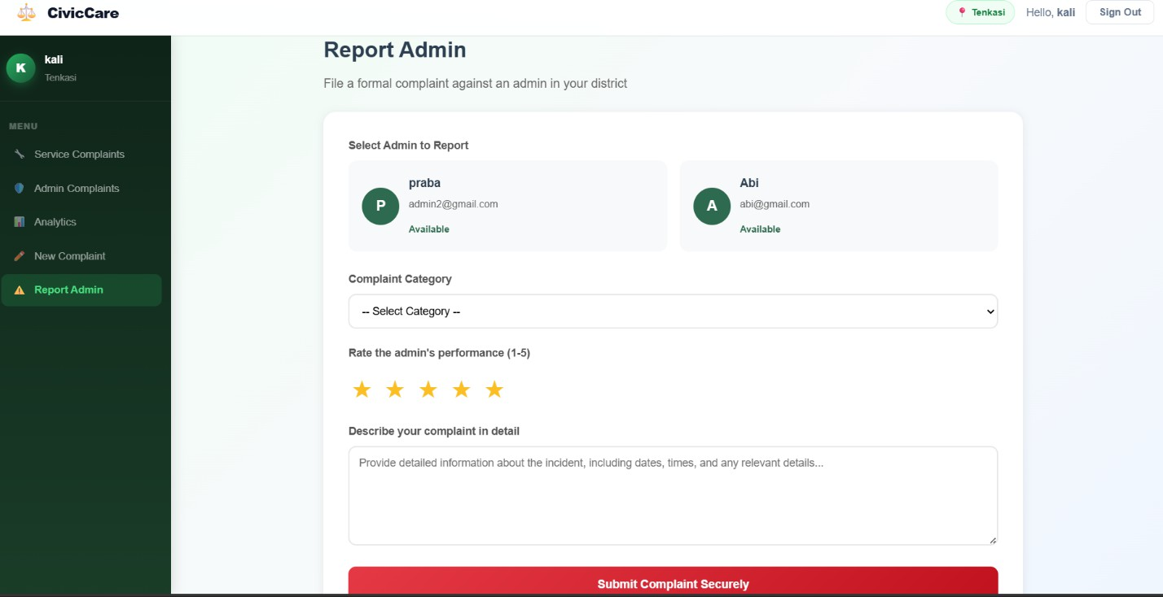
Fig 5.3 Report Admin Page

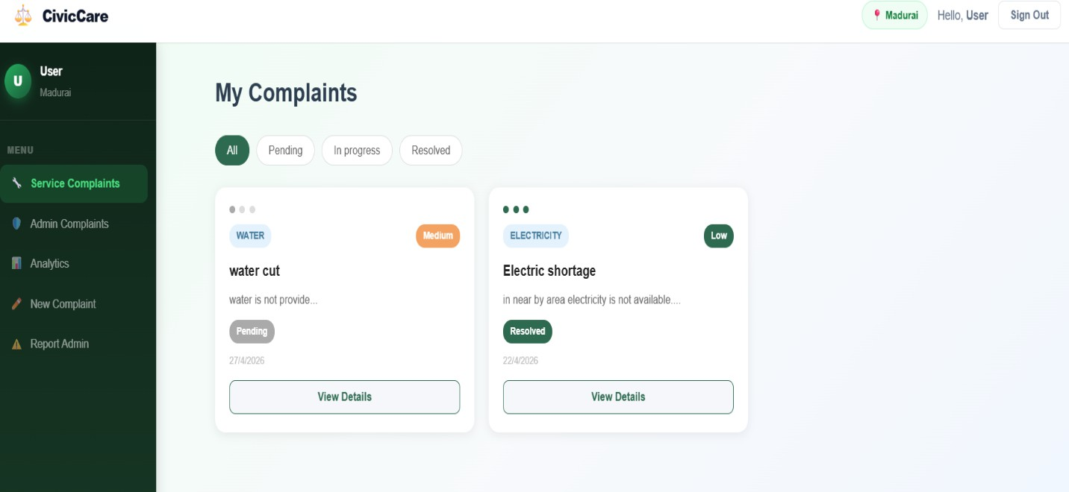
Fig 5.4 Service Complaints Page

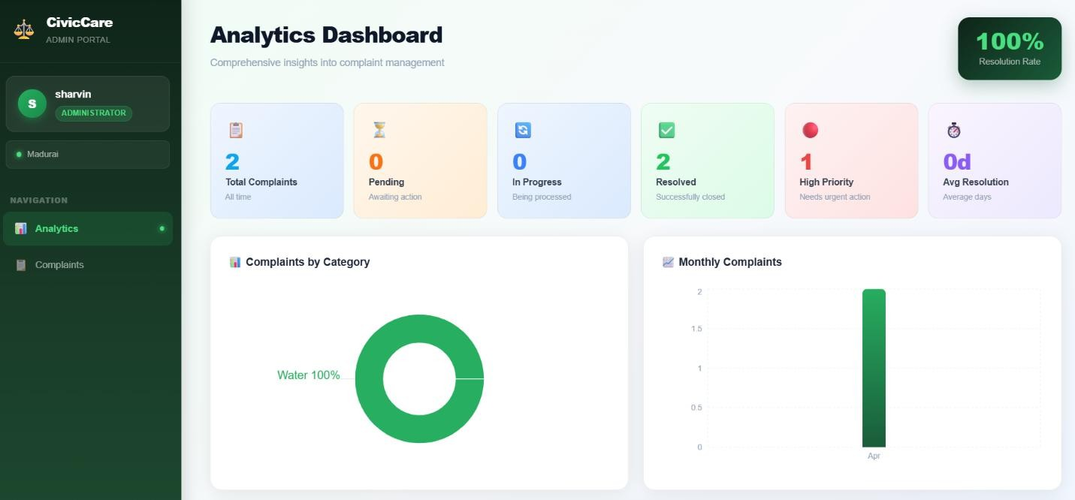
Fig 5.5 Admin Analytics Page

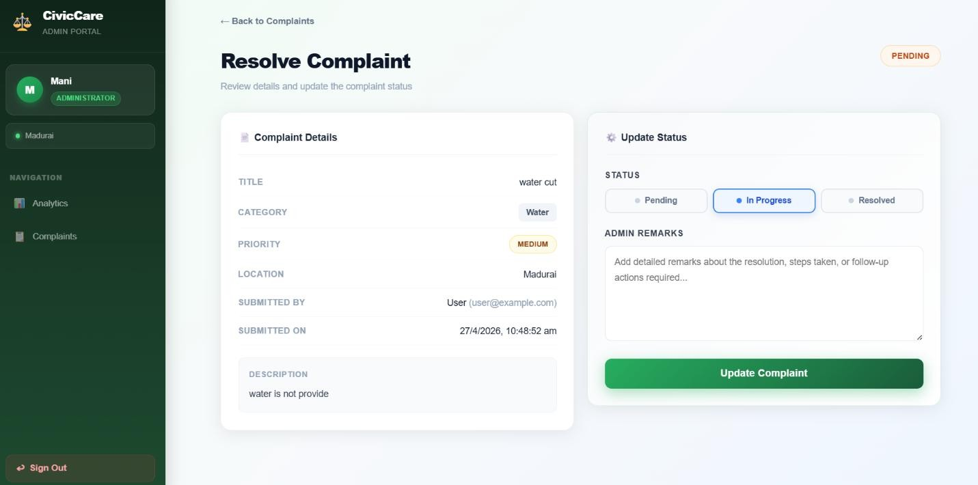
Fig 5.6 Resolve Complaint Page

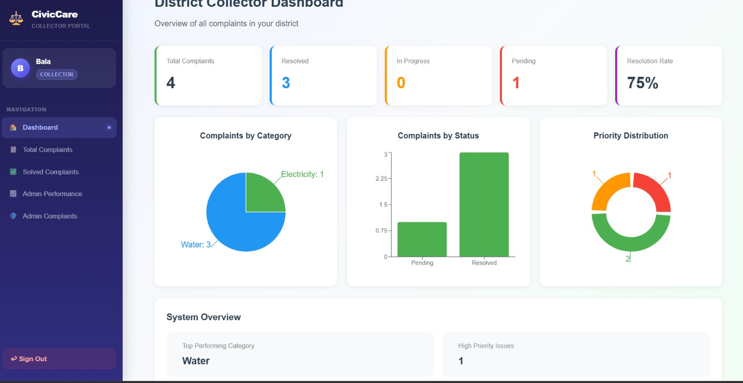
Fig 5.7 Collector Dashboard

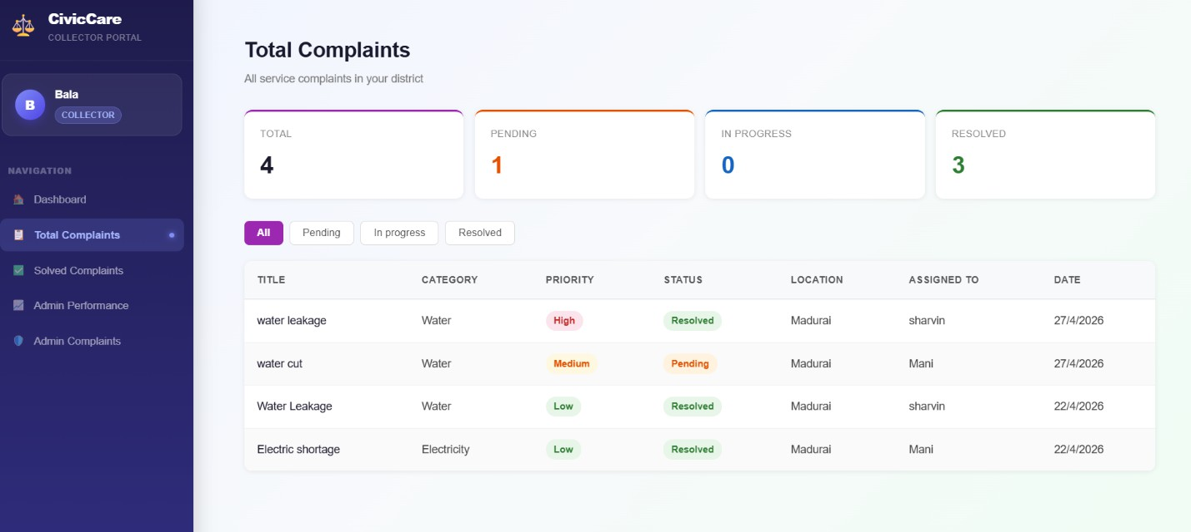
Fig 5.8 Total District Complaint Page

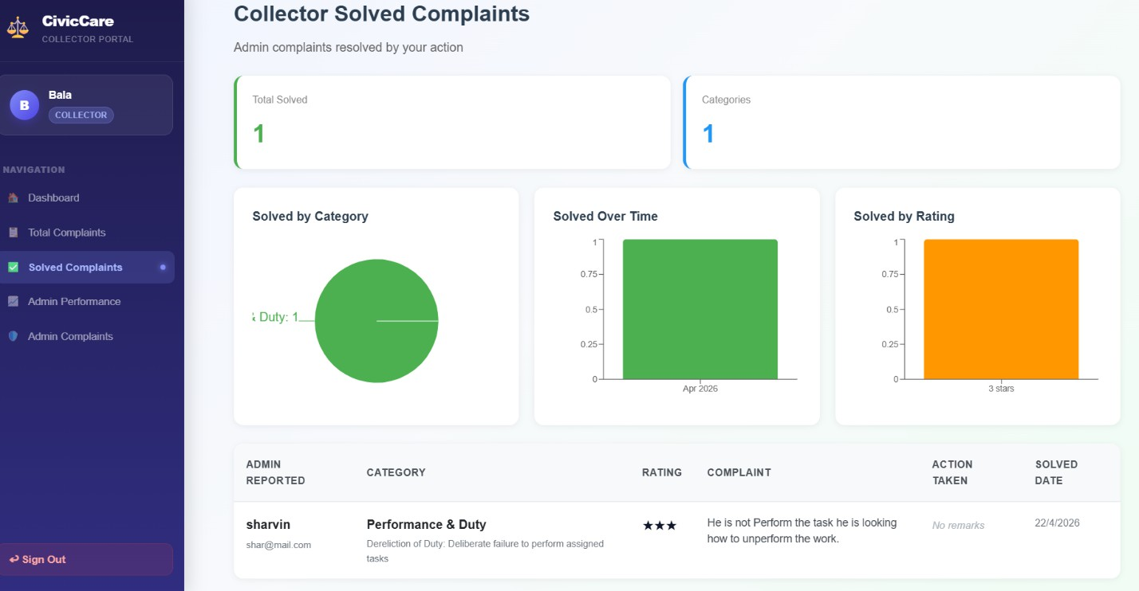
Fig 5.9 Collector Solved Complaint Page
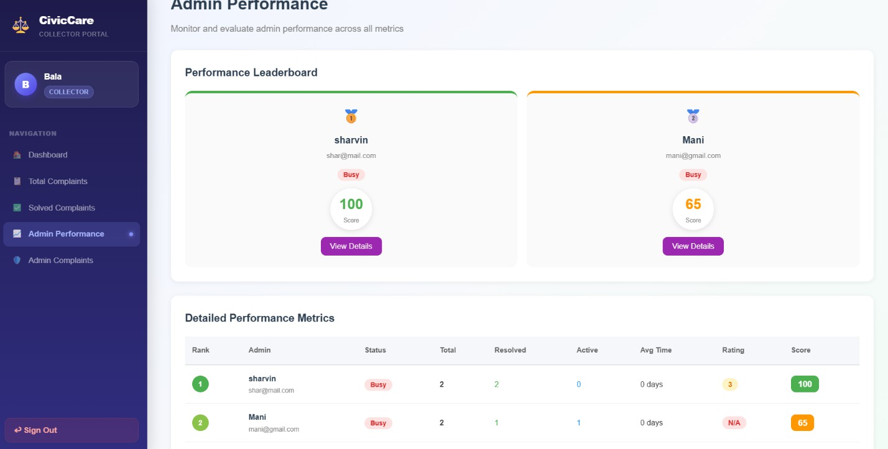
Fig 5.10 Admin Performance Metrics Page

CHAPTER 6
CONCLUSION AND FUTURE ENHANCEMENTS

Conclusion
The Government Complaint Management System successfully delivers a comprehensive digital grievance redressal platform for Tamil Nadu citizens. The project demonstrates how modern full-stack web technologies can be applied to real-world governance challenges. Key achievements include the three-role RBAC architecture providing appropriate access control, the intelligent complaint submission pipeline with keyword-driven priority detection and hotspot identification, the fair admin assignment algorithm ensuring balanced workload distribution, and the multi-factor performance scoring system enabling objective admin evaluation by district collectors.
The Recharts-powered analytics dashboards provide actionable insights to both administrators and collectors, surfacing complaint trends, category distributions, and resolution performance metrics. The admin accountability mechanism — where citizens can formally report poor service and affect official performance scores — represents an innovative approach to public sector accountability. The system aligns with SDG 16 (Strong Institutions), SDG 11 (Sustainable Cities), and SDG 10 (Reduced Inequalities) by creating a transparent, equitable, and data-driven public service platform.

Future Enhancements

- Email and SMS Notifications
Automated alerts to citizens when their complaint status changes, and to admins when new complaints are assigned, using NodeMailer and an SMS gateway integration. This would replace the need for citizens to actively check the portal for updates.

Real-Time Chat
WebSocket-based communication channel between citizens and assigned admins for complaint clarification without requiring in-person meetings, enabling faster resolution of ambiguous complaints.

Mobile Application
A React Native mobile app extending the portal's reach to non-desktop users, particularly in rural districts where mobile usage significantly exceeds desktop usage.

Geolocation Integration
GPS-based location tagging for complaints, enabling map visualization of complaint clusters and more precise hotspot detection using coordinate-based proximity rather than text-based location matching.

Advanced Analytics with Predictive Modeling
Time-series forecasting to predict complaint volume spikes and proactively allocate administrative resources before a surge occurs, shifting the system from reactive to predictive governance.

Multi-Language Support
Tamil language interface to ensure accessibility for citizens who are not proficient in English, significantly expanding the system's reach across all demographics in Tamil Nadu.

APPENDIX – A SOURCE CODE

User Model (models/User.js)
const mongoose = require('mongoose'); const bcrypt = require('bcryptjs');
const userSchema = new mongoose.Schema({ name: { type: String, required: true },
email: { type: String, required: true, unique: true }, password: { type: String, required: true },
role: {
type: String,
enum: ['user', 'admin', 'collector'], default: 'user'
},
district: { type: String, required: true }, isAvailable: {
type: Boolean, default: true, required: function() {
return this.role === 'admin' || this.role === 'collector';
}
},
}, { timestamps: true });
userSchema.methods.matchPassword = async function (enteredPassword) { return await bcrypt.compare(enteredPassword, this.password);
};
module.exports = mongoose.model('User', userSchema);

Complaint Model (models/Complaint.js)
const mongoose = require('mongoose');
const complaintSchema = new mongoose.Schema({
userId: { type: mongoose.Schema.Types.ObjectId, ref: 'User', required: true },

title: { type: String, required: true }, description: { type: String, required: true }, category: {
type: String,
enum: ['Electricity', 'Water', 'Road', 'Sanitation', 'Other'], required: true
},
district: { type: String, required: true }, location: { type: String },
image: { type: String }, status: {
type: String,
enum: ['Pending', 'In Progress', 'Resolved'], default: 'Pending'
},
priority: { type: String,
enum: ['High', 'Medium', 'Low'], default: 'Low'
},
assignedAdmin: {
type: mongoose.Schema.Types.ObjectId, ref: 'User', default: null
},
isFrequentArea: { type: Boolean, default: false }, resolvedAt: { type: Date },
remarks: { type: String, default: '' }, rating: { type: Number, min: 1, max: 5 }, feedback: { type: String, default: '' }, suggestion: { type: String, default: '' }
}, { timestamps: true });
module.exports = mongoose.model('Complaint', complaintSchema);

Authentication Controller (controllers/authController.js)
const User = require('../models/User'); const jwt = require('jsonwebtoken'); const bcrypt = require('bcryptjs'); const generateToken = (id) =>
jwt.sign({ id }, process.env.JWT_SECRET, { expiresIn: '7d' }); exports.register = async (req, res) => {
try {
const { name, email, password, district, role } = req.body;
if (!district) return res.status(400).json({ message: 'District is required' }); const exists = await User.findOne({ email });
if (exists) return res.status(400).json({ message: 'Email already registered' }); const hashedPassword = await bcrypt.hash(password, 10);
const user = await User.create({
name, email, password: hashedPassword, role: role || 'user', district
});
res.status(201).json({
token: generateToken(user._id), user: { id: user._id, name: user.name,
email: user.email, role: user.role, district: user.district }
});
} catch (err) {
res.status(500).json({ message: err.message });
}
};
exports.login = async (req, res) => { try {
const { email, password, role } = req.body; const user = await User.findOne({ email });
if (!user || !(await user.matchPassword(password))) {
return res.status(400).json({ message: 'Invalid credentials' });

if (user.role !== role) {
return res.status(403).json({ message: 'Not a ' + role + ' account' });
}
res.json({
token: generateToken(user._id), user: { id: user._id, name: user.name,
email: user.email, role: user.role, district: user.district }
});
} catch (err) {
res.status(500).json({ message: err.message });
}
};

Admin Performance Engine (controllers/adminComplaintController.js)

exports.getAdminPerformance = async (req, res) => { try {
const Complaint = require('../models/Complaint'); const admins = await User.find(
{ role: 'admin', district: req.user.district }, 'name email isAvailable district'
);

const performance = await Promise.all(admins.map(async a => {

const totalAssigned = await Complaint.countDocuments({ assignedAdmin: a._id }); const resolvedComplaints = await Complaint.find({
assignedAdmin: a._id, status: 'Resolved', resolvedAt: { $exists: true }
});

const resolved = resolvedComplaints.length;

const delayed = await Complaint.countDocuments({ assignedAdmin: a._id, status: { $ne: 'Resolved' },
createdAt: { $lt: new Date(Date.now() - 3 * 24 * 60 * 60 * 1000) }

});

const avgResMs = resolved > 0

? resolvedComplaints.reduce((s, c) =>

s + (new Date(c.resolvedAt) - new Date(c.createdAt)), 0) / resolved return { _id: a._id, name: a.name, email: a.email,
district: a.district, totalAssigned, resolved, delayed, avgResolutionTime,
avgRating: Number(avgRating), overallScore };

}));

performance.sort((a, b) => b.overallScore - a.overallScore); res.json(performance);
} catch (err) {

res.status(500).json({ message: err.message });

}

};

Frontend Login.jsx
import { useState } from "react";

import { useNavigate, Link } from "react-router-dom";

import { useAuth } from "../context/AuthContext"; import API from "../api/axios";

const roles = [

{ id: "user", label: "Citizen", icon: , desc: "File complaints" },

{ id: "admin", label: "Admin", icon: , desc: "Manage district" },

{ id: "collector", label: "Collector", icon: , desc: "Oversee regions" },

];

export default function Login()

const [form, setForm] = useState({ email: "", password: "", role: "user" }); const [error, setError] = useState("");
const [loading, setLoading] = useState(false); const { login } = useAuth();
const navigate = useNavigate();

const handleSubmit = async (e) => { e.preventDefault();
setError(""); setLoading(true); try {
const { data } = await API.post("/auth/login", form); login(data.user, data.token);
if (data.user.role === "admin") navigate("/admin/analytics");

else if (data.user.role === "collector") navigate("/collector/dashboard"); else navigate("/dashboard");

} catch (err) {

setError(err.response?.data?.message || "Login failed");

}

setLoading(false);

};

const selectedRole = roles.find(r => r.id === form.role); return (
<div style={S.container}>

{/* Left branding panel */}

<div style={S.brandPanel}>

<div style={S.brandContent}>

<div style={S.brandIcon}></div>

<h1 style={S.brandTitle}>CivicCare</h1>

<p style={S.brandSubtitle}>Government Complaint Management System</p>

<div style={S.brandFeatures}>

{['File complaints instantly', 'Track resolution status', 'Transparent governance', 'AI-powered insights'].map(f => (
<div key={f} style={S.featureItem}>

<span style={S.featureDot}>✓</span>

<span>{f}</span>

</div>

))}

</div>

</div>

<p style={S.brandFooter}>© 2025 CivicCare. Empowering citizens.</p>

</div>

{/* Right login form */}

<div style={S.formPanel}>

<div style={S.formCard}>

<div style={S.formHeader}>

<h2 style={S.formTitle}>Welcome back</h2>

<p style={S.formSubtitle}>Sign in to continue to your portal</p>

</div>

{error && <div style={S.errorAlert}><span>⚠</span> {error}</div>}

<form onSubmit={handleSubmit}>

{/* Role Selector */}

<div style={S.roleSection}>

<p style={S.sectionLabel}>Select your role</p>

<div style={S.roleGrid}>

{roles.map(r => (

<button key={r.id} type="button"

style={{ ...S.roleBtn, ...(form.role === r.id ? S.roleBtnActive : {}) }} onClick={() => setForm({ ...form, role: r.id })}>
<span style={S.roleIcon}>{r.icon}</span>

<span style={S.roleLabel}>{r.label}</span>

<span style={S.roleDesc}>{r.desc}</span>

{form.role === r.id && <div style={S.roleCheckmark}>✓</div>}

</button>

))}

</div>

</div>

<div style={S.inputGroup}>

<label style={S.label}>Password</label>

<div style={S.inputWrap}>

<span style={S.inputIcon}></span>

<input style={S.input} type="password" placeholder="Enter your password" value={form.password} onChange={e => setForm({ ...form, password: e.target.value })} required />
</div>

</div>

<button style={{ ...S.submitBtn, ...(loading ? S.submitBtnLoading : {}) }} type="submit" disabled={loading}>
{loading ? (

<span style={{ display: 'flex', alignItems: 'center', justifyContent: 'center', gap: 10 }}>

<span style={{ width: 18, height: 18, border: '2.5px solid rgba(255,255,255,0.3)', borderTopColor: '#fff', borderRadius: '50%', animation: 'spin 0.7s linear infinite', display: 'inline-block' }}></span
</span>

) : `Sign in as ${selectedRole?.label}`}

</button>

</form>

{form.role === "user" && (

<p style={S.registerLink}>

New citizen? <Link to="/register" style={S.link}>Create account →</Link>

REFERENCES

[1]. MongoDB Documentation – Mongoose ODM and Aggregation Pipelines.
Available: https://mongoosejs.com/docs/
[2]. Express.js Documentation – REST API Design and Middleware. Available: https://expressjs.com/
[3]. React Documentation – Hooks, Context API, and React Router. Available: https://react.dev/
[4]. Recharts Documentation – React Charting Library. Available: https://recharts.org/
[5]. JSON Web Tokens (JWT) – Authentication Best Practices. Available: https://jwt.io/
[6]. Multer Documentation – Node.js File Upload Middleware. Available: https://github.com/expressjs/multer
[7]. Tamil Nadu e-Governance Agency – Digital Public Service Delivery Frameworks. Available: https://tnega.tn.gov.in/
[8]. Bcrypt.js Documentation – Password Hashing for Node.js. Available: https://github.com/dcodeIO/bcrypt.js/
[9]. Ministry of Electronics and Information Technology (MeitY) – e- Governance Standards.
[10]. Zod Schema Validation Documentation. zod.dev, 2024. [TypeScript-first schema declaration and validation library used for form handling.]
[11]. James Urquhart. REST API Design Rulebook. Reilly Media, 2011. [Best practices for REST API design applied in backend endpoint architecture.]

